**CALL FOR PAPERS**

Special Session on ‘XXX’ **(Please add here the Title of the special session)**

**2025 6th International Conference on Machine Learning and Human-Computer Interaction**

**Conference Website:** [**http://mlhmi.org/**](http://mlhmi.org/)

**March 4-6, 2025 | Kawasaki, Japan**



**Conference Venue: Meiji University Ikuta Campus**

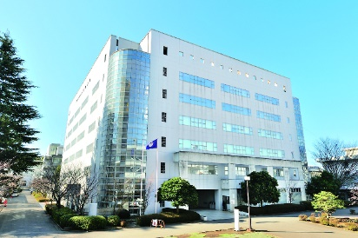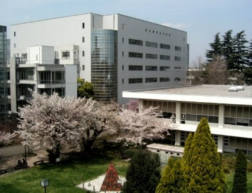

**ORGANIZED AND CHAIRED by**

Organizer 1 name and affiliation

Email address

Organizer 2 name and affiliation

Email address

**SPECIAL SESSION DESCRIPTION** (no more than 150 words)

Please add a short description of the topic

**TOPICS COVERED** (no more than 5)

* Topic 1
* Topic 2
* Topic 3
* Topic 4
* Topic 5

**Schedule:**

Deadline for submission of the paper (s) to the Electronic Submission System by selecting the desired special session – October 15, 2024

Notification of acceptance – November 15, 2024

Supported by:



Indexed by:  
 